### UNIT - I

**Reference Book -** [“Virtualization Essentials” by Matthew Portnoy](https://drive.google.com/file/d/1CgUr300SVX2bidyiRMxY8CWqzrj0EGmk/view?usp=drive_link)

#### Chapter 1 - Understanding software virtualization software operations

1. **What is meant by "virtualization" in computing, and how does it relate to the abstraction of physical resources?**

* In computing, "virtualization" refers to the process of abstracting physical computing resources into logical entities. This allows multiple operating systems or applications to run on a single physical server, effectively maximizing resource utilization and improving efficiency.
* By virtualizing resources such as CPUs, memory, storage, and network connectivity, organizations can manage and allocate these resources more flexibly and efficiently, minimizing hardware costs and maximizing performance.
* Virtualization enables the creation of virtual machines (VMs), each of which operates independently, as if it were a separate physical computer. This operation is facilitated by a software layer known as a hypervisor, which manages the VMs and their access to the physical hardware.
* The hypervisor abstracts the physical components, allowing for dynamic resource allocation and management, which significantly simplifies data center operations and enhances scalability and availability.
* In essence, virtualization transforms the way computing resources are utilized by creating a virtual environment that abstracts the physical layer, leading to more streamlined operations and reduced costs in managing hardware resources

1. **What role does virtualization play in improving efficiency and flexibility in resource utilization?**

Virtualization plays a crucial role in improving efficiency and flexibility in resource utilization in several key ways:

1. **Resource Optimization**: By allowing multiple virtual machines (VMs) to run on a single physical server, virtualization maximizes the use of available hardware resources. This reduces the need for physical servers, as multiple workloads can be consolidated onto fewer machines, leading to lower hardware costs and energy consumption , .
2. **Dynamic Resource Allocation**: Virtualization enables organizations to allocate resources dynamically according to their current needs. For instance, if one virtual machine experiences a spike in demand, resources can be reallocated from less busy VMs without downtime, enhancing flexibility and responsiveness to changing workloads , .
3. **Isolation and Security**: Each VM operates in isolation, meaning that issues in one virtual environment do not affect others. This allows for testing and development environments to be set up without risking the stability of production systems, thereby improving operational flexibility.
4. **Simplified Management**: Virtualized environments can be managed more easily through centralized management tools, which streamline administration tasks such as provisioning, monitoring, and maintenance. By reducing the time spent on routine administrative tasks, IT staff can focus on innovation and higher-value activities .
5. **Scalability**: Virtualization provides the foundation for cloud computing, enabling organizations to scale their resources up or down according to demand. This elasticity allows businesses to respond quickly to changing market conditions and user requirements .
6. **What is the role of a Virtual Machine Monitor (VMM) in virtualization, and how is it similar to or different from a hypervisor?**

A Virtual Machine Monitor (VMM) plays a crucial role in the virtualization process by enabling the execution and management of multiple virtual machines (VMs) on a single physical host. The terms "Virtual Machine Monitor" and "hypervisor" are often used interchangeably, but there are subtle distinctions in their usage and context.

**Role of a Virtual Machine Monitor (VMM)**

1. **Management of Virtual Machines**: The VMM is responsible for creating, managing, and controlling the VMs. It allocates physical resources (such as CPU, memory, and storage) to each VM, ensuring that they operate independently and effectively .
2. **Abstraction of Hardware**: The VMM abstracts the underlying physical hardware from the VMs, providing a consistent virtual environment for each guest operating system. This abstraction allows for the smooth execution of applications across different virtualized environments.
3. **Resource Allocation**: It dynamically manages the distribution of physical resources among the VMs, adjusting resource allocation as needed to optimize performance and efficiency .
4. **Isolation and Security**: The VMM ensures that each VM is isolated from the others, preventing conflicts and enhancing security. An issue in one VM does not affect the operation of other VMs running on the same host.

**Similarities and Differences Between VMM and Hypervisor**

* **Similarities**
  + Both VMM and hypervisor refer to the technology that enables virtualization, allowing multiple VMs to run on a single physical host.
  + They serve the same fundamental functions of resource management, abstraction, and isolation for virtualized environments.
* **Differences**:
  + While "hypervisor" is a more modern and widely-used term, particularly in cloud computing contexts, "VMM" has historical significance and is often associated with earlier virtualization efforts.
  + The term hypervisor can further be categorized into two types: Type 1 (bare-metal) hypervisors, which run directly on the hardware without a host operating system, and Type 2 (hosted) hypervisors, which run on top of a standard OS. The term VMM does not typically imply this distinction .

1. Why is fidelity an important property for a VMM, and how does it impact the experience of running virtual machines?
2. **What is meant by "isolation" or "safety" in the context of virtualization, and why is it necessary for proper functioning?**

In the context of virtualization, "isolation" or "safety" refers to the capability of a Virtual Machine Monitor (VMM) or hypervisor to ensure that each virtual machine (VM) operates independently and securely, without interference from other VMs running on the same physical host. This concept is critical for several reasons:

**Importance of Isolation in Virtualization**

1. **Independent Operation**: Isolation ensures that each VM can run its operating system and applications without being affected by other VMs. This independence is essential for maintaining the stability and reliability of each VM's operations, especially in environments where critical applications may be running alongside less critical ones .
2. **Enhanced Security**: By isolating VMs, the hypervisor helps prevent breaches and malicious activities from spreading across the system. If one VM is compromised or experiences a failure, the isolation minimizes the risk of that issue impacting other VMs or the underlying host.
3. **Resource Control**: Isolation allows the hypervisor to manage and allocate resources (such as CPU, memory, and storage) to each VM based on its specific needs and priorities. This ensures fair resource distribution while preventing one VM from monopolizing resources, which could degrade performance for others , .
4. **Testing and Development**: In isolation, developers can test applications in a controlled environment without risking disruption to production systems. This capability fosters innovation and iteration while safeguarding critical business operations .
5. **Fault Tolerance**: Isolation contributes to fault tolerance, as problems in one VM (such as crashes or bugs) do not propagate to others. This factor is vital for maintaining overall system integrity and uptime in virtualized environments .
6. **Explain different types of virtualization with diagrams.**

Virtualization encompasses several different types, each serving unique purposes and use cases. Below are common types of virtualization along with brief descriptions and illustrative diagrams for better understanding:

**1. Server Virtualization**

**Description**: Server virtualization allows multiple virtual servers (or virtual machines, VMs) to run on a single physical server. This type optimizes resource utilization and reduces hardware costs.

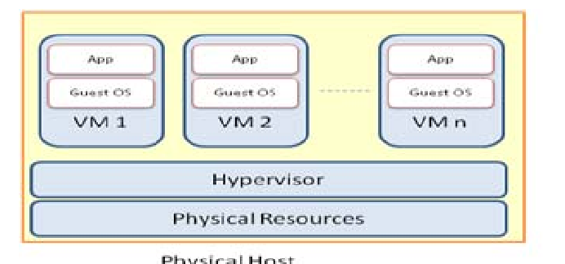

*In this illustration, multiple VMs operate independently on one physical server, each with its own operating system and applications.*

**2. Desktop Virtualization**

**Description**: Desktop virtualization allows a user’s desktop environment to be hosted on a centralized server rather than on a local device. This enables access to the desktop from any device with a network connection.

**Diagram**:

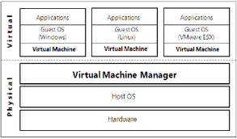

*Here, multiple client devices access a virtual desktop environment from a central server, allowing for a consistent user experience across devices.*

**3. Storage Virtualization**

**Description**: Storage virtualization abstracts physical storage resources into a single logical storage pool. This allows for better storage management, efficiency, and flexibility across storage systems.

**Diagram**:

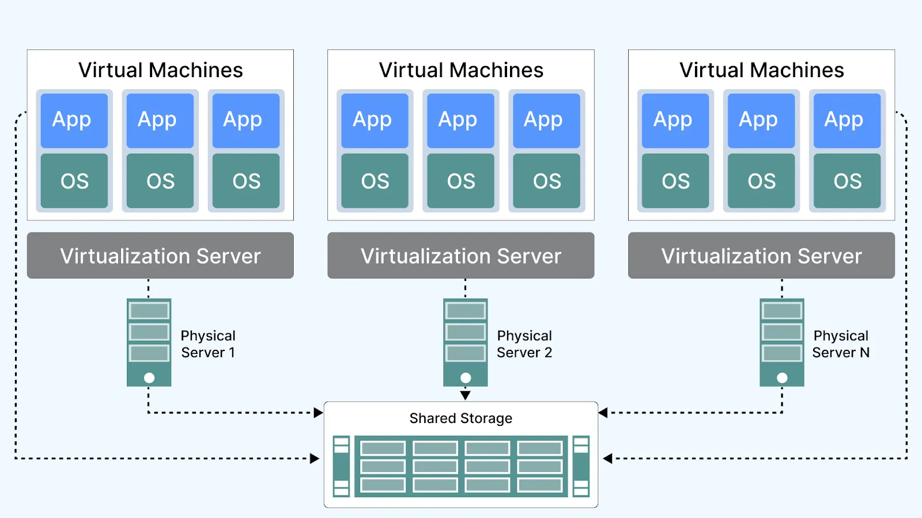

*The storage resources from various physical disks are combined into a unified storage pool that can be managed logically rather than physically.*

**4. Network Virtualization**

**Description**: Network virtualization creates a virtualized network environment, abstracting network resources from the physical infrastructure. It allows for the creation of isolated virtual networks within a single physical network.

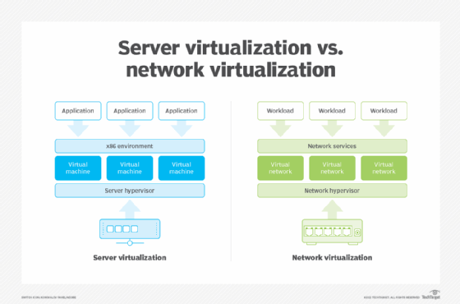

*In this diagram, a virtual switch connects multiple VMs, enabling them to communicate over a virtualized network while maintaining isolation from other VMs' networks.*

**5. Application Virtualization**

**Description**: Application virtualization encapsulates applications from the underlying operating system. This allows applications to run in user environments without being installed directly on the operating system.

**Diagram**:

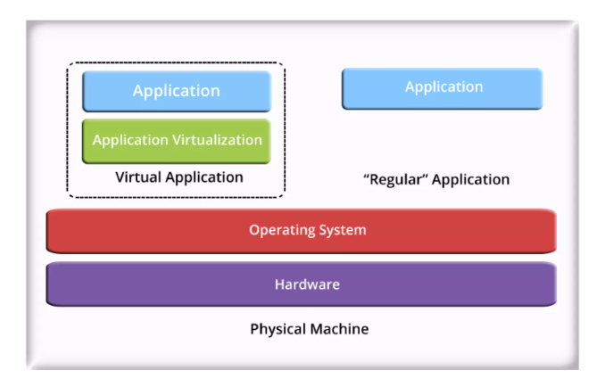

*This representation shows that applications are virtualized within their containers, allowing smooth deployment and operation without direct installation on the host OS.*

1. What is Moore’s Law, and who originally proposed it?
2. How has Moore's Law influenced the development of semiconductor technology over the years?
3. What does Moore’s Law predict about the number of transistors on a chip and their impact on computing power?
4. How does Moore’s Law relate to the increase in performance and decrease in cost of electronic devices?
5. How has Moore’s Law contributed to the rapid advancement of computing devices like smartphones, laptops, and servers?
6. In what ways has Moore’s Law driven innovations in fields such as artificial intelligence, big data, and cloud computing?
7. How does Moore’s Law affect the pricing and availability of consumer electronics?

#### 

#### **Notes on Moore's Law**

**Introduction to Moore's Law**

* **Definition:** *Moore’s Law* is the observation made by Gordon Moore, co-founder of Intel, in 1965, that **processing power** of computer chips doubles approximately **every 18 months**.
* **Key Insights:**
  + **Exponential Growth:** This doubling trend applies not just to processing power but also affects other technological areas like memory capacity, megapixel count in cameras, etc.
  + **Duration of Validity:** While the exponential growth might eventually face limitations, scientists believe it will continue for **20 to 100+ years**.

**Technological Growth and Moore’s Law**

* **Key Examples:**
  + Digital cameras evolved from under **1 megapixel** to over **24 megapixels** and higher-end models offering much more.
  + The memory (RAM) in computers evolved from kilobytes to **gigabytes**—a massive increase of two orders of magnitude.

**Impact of Moore’s Law on Server Technology**

* **Server Growth and Upgrades:**
  + Server technology continues to advance rapidly, as servers are often **replaced** or **leased** in intervals of **3-5 years**.
  + Due to Moore’s Law, the **newer servers** are often **significantly more powerful** than older ones. For example, in a span of 6 years, processing power may double multiple times (4 times or 16 times more powerful than the original server).

**Server Replacement Model**

* **Headroom Concept:**
  + When servers are purchased, they often come with extra capacity (headroom) to handle future growth or unexpected demand. This headroom is calculated based on the **projected needs** of the organization.
  + Over time, **servers with larger capabilities** are replaced with even **more powerful models**, sometimes leading to **90% unused capacity** in the servers, contributing to **low server utilization** in data centers.
* **Example of Server Upgrade:**
  + **End of Lease 1 (3 years):** A new server is purchased, which is **twice as powerful** as the previous one.
  + **End of Lease 2 (6 years):** A new server is purchased, **16 times more powerful** than the original server (doubling power 4 times).

**Effect of Moore's Law on Data Centers**

* **Server Utilization:**
  + **Under-utilization** is common in data centers. After a few upgrades, the **actual server workload** doesn't scale proportionally to the increase in processing power.
  + Typical utilization rates in data centers can average **10-15%**, with some servers under-utilized by as much as **95%**.
* **Impact on Resource Allocation:**
  + Even though servers are increasingly more powerful, most of their **processing power** is often not fully utilized, leading to inefficiencies. This is why **virtualization** techniques (like virtual machines) have become essential to better allocate these unused resources.

**Moore’s Law in Context:**

* **Impact on Consumer Devices:**
  + Technology advancements such as smartphones, tablets, and computers are increasingly more powerful thanks to Moore’s Law.
  + Devices that were once top-tier are now **outdated quickly** as technology improves and consumers regularly **upgrade** to newer models.

**Future of Moore’s Law:**

* + Despite the potential physical limitations of transistor sizes, **research in quantum computing** and other innovations could extend the principle of Moore’s Law into the future.

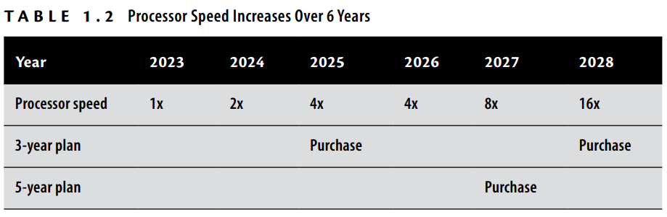

1. What is the concept of "containment" in virtualization, and how did it benefit companies in terms of hardware maintenance and cost savings?
2. **Explain Desktop virtualization and application virtualization.**

**Desktop Virtualization:**

* Desktop environments (OS + apps) run on centralized servers in data centers.
* Users access virtual desktops via **thin clients** or other devices.
* **Cost-effective**: Thin clients are cheaper, more reliable, and use less power than PCs.
* **Centralized management**: Software updates, patches, and security are easier to manage.
* **Data security**: Data is stored in the data center, reducing risk of data loss from stolen devices.
* **Improved network efficiency**: Reduced data traffic between client and server.

**Application Virtualization:**

* Applications run on a server and are accessed remotely, not installed on local devices.
* **Simplifies deployment**: Centralized management and updates reduce the need for device-by-device installation.
* **Prevents conflicts**: Encapsulates software and its dependencies, avoiding compatibility issues.
* **Containers**: Share a single operating system, improving resource efficiency and scalability.
* **Flexibility**: Applications can be accessed on various devices without local installations.

#### 

#### Chapter 2 - Understanding hypervisors

1. **What is a hypervisor, and what role does it play in virtualization, explained with diagrams.**

* A hypervisor is a critical component in server virtualization. It acts as a software layer that **enables the creation and management of virtual machines (VMs) by abstracting the physical hardware** and allocating resources such as CPU, memory, and storage to each VM.
* Hypervisors ensure that multiple VMs run simultaneously on a single physical machine (host), effectively utilizing the resources while maintaining isolation between the VMs.

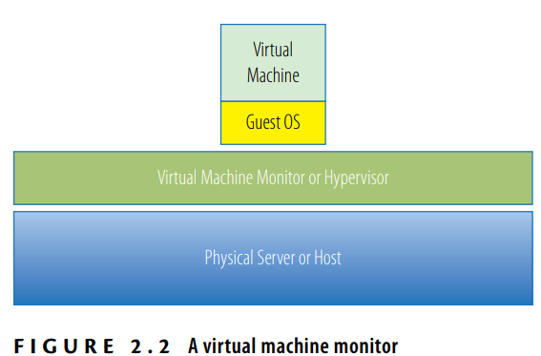

* Without a hypervisor, multiple virtual machines would want simultaneous control of the hardware, which would result in chaos.
* The hypervisor manages the interactions between each virtual machine and the hardware that the guests all share.
* **Types of Hypervisors**

There are two main types of hypervisors:

1. Type 1 Hypervisor (Bare-metal): runs directly on the physical hardware of the host machine
2. Type 2 Hypervisor (Hosted): runs on top of a host operating system, which in turn runs on the physical hardware.

**Role of the Hypervisor in Virtualization**

The role of the hypervisor is to create an abstraction layer between the physical hardware and the virtual machines running on top of it. This abstraction allows multiple operating systems to run independently on a single physical server.

The key roles of the hypervisor include:

1. **Resource Allocation:** The hypervisor allocates physical resources like CPU, memory, and storage to each virtual machine.
2. **Isolation and Security:** It ensures that each virtual machine operates independently without interfering with others.
3. **VM Management:** The hypervisor provides tools to create, start, stop, and manage virtual machines.
4. **Virtual Device Emulation:** It emulates hardware devices for virtual machines, enabling them to interact with virtualized hardware.
5. **What is the difference between a Type 1 (bare-metal) hypervisor and a Type 2 (hosted) hypervisor? Give popular examples of both hypervisors.**

| **Feature** | **Type 1 Hypervisor (Bare-metal)** | **Type 2 Hypervisor (Hosted)** |
| --- | --- | --- |
| Installation | Installed directly on physical hardware | Installed on top of an existing host OS |
| Interaction with Hardware | Direct access to physical hardware | Access to hardware through the host OS |
| Performance | Typically more efficient, as it runs directly on the hardware | Less efficient due to the extra layer (host OS) |
| Examples | VMware ESXi, Microsoft Hyper-V, Xen | VMware Workstation, Oracle VirtualBox, Parallels Desktop |
| Use Case | Used in data centers, large-scale virtualization | Typically used for personal or smaller-scale virtualization |
| Management | Managed through dedicated tools and interfaces | Managed through the host OS and additional management tools |
| Security | More secure due to fewer layers and direct hardware control | Slightly less secure due to the dependency on the host OS |

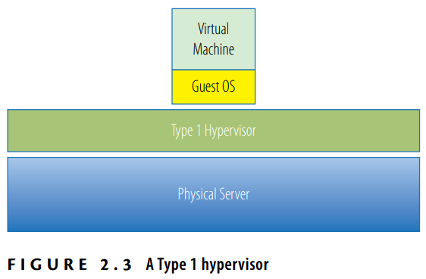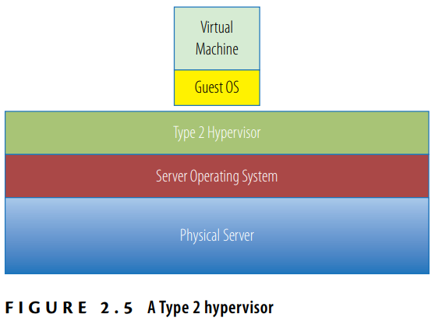

1. **How does a hypervisor manage physical resources like CPU, memory, and storage among multiple virtual machines?**

A hypervisor manages physical resources like CPU, memory, and storage among multiple virtual machines (VMs) through resource allocation, isolation, and virtualization techniques. Here's how it manages each of these resources:

**1. CPU Management:**

Virtual CPUs (vCPUs): The hypervisor allocates physical CPU cores or threads to each VM by creating virtual CPUs (vCPUs). Each vCPU is mapped to a physical core or thread, and the hypervisor schedules CPU time for each VM based on demand.

Scheduling: The hypervisor uses scheduling algorithms to allocate CPU time to each VM. It ensures that each VM gets its fair share of CPU resources while minimizing conflicts between VMs. This allows multiple VMs to run simultaneously, even if they share physical CPU cores.

**2. Memory Management:**

Virtual Memory: The hypervisor assigns each VM a portion of the physical host's RAM, which is virtualized for the guest operating system running inside the VM. The hypervisor manages the memory allocation and ensures that each VM gets its allocated memory without interference from others.

**3. Storage Management:**

Virtual Disks: The hypervisor provides each VM with its own virtual disk (VMDK, VHD, etc.), which is stored on the physical storage of the host machine. Virtual disks are typically stored as files, and the hypervisor maps these files to physical storage, ensuring that each VM has access to its allocated disk space.

Storage Virtualization: The hypervisor abstracts the underlying physical storage and presents it to the VMs as virtual storage. The physical storage can be local (on the host) or remote (via network storage solutions like SAN or NAS).

**4. Resource Allocation & Isolation:**

The hypervisor ensures that resources are allocated fairly and that VMs are isolated from each other to prevent interference by Resource Limits: Administrators can set resource limits for each VM, ensuring that no single VM can consume all the resources (e.g., CPU or memory), thereby affecting others.

1. **What role do hypervisors play in supporting CPU and memory overcommitment in virtualized environments?**
2. **List out hypervisors provided by VMware, Citrix, Microsoft. Differentiate these hypervisors.**

**VMware**

1. VMware ESXi (Type 1)

2. VMware Workstation (Type 2)

3. VMware Fusion (Type 2)

**Citrix**

1. Citrix Hypervisor (formerly XenServer, Type 1)

**Microsoft**

1. Microsoft Hyper-V (Type 1)

2. Hyper-V Server (Type 1, Free version)

| **Feature** | **VMware ESXi** | **Citrix Hypervisor** | **Microsoft Hyper-V** |
| --- | --- | --- | --- |
| Type | Type 1 (Bare-metal) | Type 1 (Bare-metal) | Type 1 (Bare-metal) |
| Target Users | Large enterprises, data centers | Enterprises, VDI, cloud infrastructure | Enterprises, Windows-centric environments |
| Cost | Paid (with free version for basic use) | Free and paid versions available | Free (Hyper-V Server) or included in Windows Server |
| Performance | High (direct access to hardware) | High (optimized for Xen-based virtualization) | High (integrated with Windows Server) |
| Management Tools | VMware vCenter, ESXi Web Client | XenCenter, Command Line Interface | Hyper-V Manager, Microsoft System Center |
| Integration | Broad compatibility with multiple OS platforms | Tight integration with Citrix products | Best integration with Windows OS and Microsoft services |
| Resource Efficiency | Very efficient, especially in large-scale environments | Efficient in server and desktop virtualization | Efficient, especially for Windows-based workloads |
| Guest OS Support | Wide range of OS (Linux, Windows, etc.) | Linux, Windows, Unix-like systems | Linux, Windows, FreeBSD |

#### 

#### Chapter 3 - Understanding virtual machines

1. What are virtual machines? Explain its directory structure (file system) in detail.

A **Virtual Machine (VM)** is a software-based emulation of a physical computer, running an operating system and applications just like a physical machine. The concept of a VM is integral to **server virtualization**, where the hypervisor abstracts the underlying physical hardware, allowing multiple virtual machines to run on a single physical host. VMs are used to increase resource utilization, isolate workloads, provide flexibility, and simplify management by enabling multiple operating systems to run concurrently on a single physical machine.

**VM Directory Structure (File System)**

The **directory structure** or **file system** of a Virtual Machine typically consists of several files that represent the VM’s configuration, operating system, virtual hardware, and data. These files are stored on the physical host and allow the VM to function as an isolated environment. Below is a detailed explanation of the typical directory structure and the role of each file.

**1. VM Configuration Files**

These files contain the settings and configurations for the virtual machine, such as the amount of CPU, memory, disk configuration, and network settings.

* **.vmx (VMware)**: This file contains the virtual machine's configuration, including its hardware settings, network adapters, and other parameters specific to the virtual machine. It is essential for the hypervisor to know how to interact with the VM.
* **.xml (Hyper-V)**: Hyper-V uses XML files to store the configuration details of virtual machines, similar to VMware's .vmx file.

**2. Virtual Disk Files**

The virtual disk file represents the virtual machine's storage (hard drive) and is critical for the VM’s operations. These files are mapped to the actual disk or storage device and can contain all the data, operating system, applications, and configuration for the virtual machine.

* **.vmdk (VMware)**: This is the Virtual Machine Disk file used by VMware. It contains the data of the virtual machine’s disk and can be split into multiple files for easier management.
* **.vhd/.vhdx (Hyper-V)**: These are the Virtual Hard Disk files used by Microsoft Hyper-V. .vhdx is the newer format, providing enhanced capabilities over the .vhd file, including support for larger storage sizes and resilience to power failures.

**3. Snapshot Files**

Snapshots allow you to capture the state of the virtual machine at a particular moment. When you take a snapshot, a new set of files is created to store changes made after the snapshot was taken.

* **.vmsn (VMware Snapshot)**: This file stores the state of the virtual machine when the snapshot was taken, including its memory and virtual devices. The file is used for restoring the VM to that snapshot state.
* **.avhd/.avhdx (Hyper-V Snapshot)**: Hyper-V uses these files to store the differences between the snapshot and the original VM’s state. They are used in conjunction with the base virtual disk.

**4. Log Files**

Log files are created to capture the events and operations performed on the virtual machine. These are useful for troubleshooting and auditing.

* **.log (VMware)**: VMware generates log files for each virtual machine, which provide a history of the VM’s activity. These logs are useful for diagnosing errors and tracking performance.
* **vm-<number>.log (VMware)**: Multiple log files are created to track the lifecycle of the virtual machine, with each log file typically representing a certain period of activity or a specific operation like booting.

**5. Virtual Machine Swap Files**

Swap files are used when the virtual machine exceeds its allocated memory. The hypervisor uses these swap files to swap memory pages out to disk to avoid running out of memory.

* **.vswp (VMware)**: VMware creates a swap file for each running virtual machine, which is used to manage memory allocation when the VM requires more memory than the host can provide. This file is located in the same directory as the VM.

**6. Temporary and Miscellaneous Files**

These files can vary depending on the virtualization platform but are often used for temporary storage and caching purposes.

* **.nvram (VMware)**: This file stores the virtual machine's BIOS settings, such as boot order and other configurations that are not part of the VM's operating system.
* **.vmsd (VMware Snapshot Metadata)**: This file stores metadata about snapshots, including the names and states of any snapshots associated with the VM.

**Typical Directory Structure Example (VMware)**

Here’s an example directory structure for a VMware virtual machine:

/VMs

/VM_Name

VM_Name.vmx <- VM configuration file

VM_Name.vmdk <- Virtual disk file(s)

VM_Name.vmsn <- Snapshot file (if snapshot exists)

VM_Name.vmsd <- Snapshot metadata file

VM_Name.nvram <- BIOS/firmware settings

VM_Name.vswp <- Swap file

VM_Name.log <- Log file(s)

VM_Name.vmtx <- Template file (if VM is a template)

1. **Examine CPU, Memory, Network Resources, and storage in virtual machines.**

Virtual machines (VMs) depend on the hypervisor to manage physical resources like CPU, memory, networking, and storage. Here’s an overview of how the hypervisor manages these resources in a virtualized environment:

**CPU in a Virtual Machine:**

Virtual machines are allocated virtual CPUs (vCPUs) by the hypervisor, which maps them to the physical CPU cores of the host. The hypervisor schedules CPU cycles for each VM, ensuring efficient resource utilization without dedicating entire CPUs to specific VMs.

**Memory in a Virtual Machine:**

Each VM is allocated a specific amount of RAM by the hypervisor. Memory can be dynamically adjusted using techniques like ballooning, transparent page sharing, and swapping. VMs don’t directly manage physical memory but rely on the hypervisor for allocation and optimization.

**Network Resources in a Virtual Machine:**

Virtual NICs are created for each VM, connecting them to a virtual network managed by the hypervisor. These virtual networks can be isolated for security, allowing internal communication between VMs without exposure to the physical network.

**Storage in a Virtual Machine:**

VMs interact with virtual disks, which are mapped to physical storage managed by the hypervisor. These virtual disks can reside on local or network storage, abstracting the complexity of the underlying storage infrastructure from the VM.

1. **How a VM works, explain with a diagram.**

A Virtual Machine (VM) operates by being abstracted from the underlying physical hardware through the use of a hypervisor. The hypervisor acts as an intermediary between the physical hardware and the guest operating system, effectively decoupling the operating system from the hardware. This enables multiple VMs to run on the same physical machine without interference, and the guest operating systems believe they are interacting directly with the hardware when, in fact, the hypervisor is managing the resources.

**Steps in How a Virtual Machine Works:**

**Application Request:** When an application running inside a VM requires resources like CPU, memory, or storage, it sends a request to the guest operating system. The OS manages the request and passes it to the hypervisor.

**Hypervisor Role:** The hypervisor intercepts the request and decides how to allocate the requested resources. The hypervisor is responsible for managing resource requests from multiple VMs, ensuring that each VM gets a fair share of the physical host resources (CPU, memory, storage, etc.).

**Resource Allocation:** The hypervisor passes the request to the physical hardware (like CPU, memory, or disk) and then returns the result to the guest OS or VM. It ensures that the VM remains isolated from others, preventing one VM from affecting the others' performance or security.

**Seamless Interaction:** From the perspective of the guest OS, it operates as though it’s directly interacting with the physical hardware. This illusion is what allows VMs to function like standalone machines, while the hypervisor handles resource distribution.

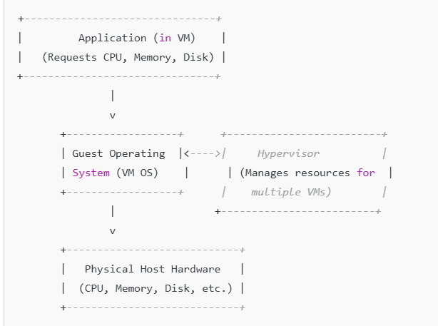

**Explanation of the Diagram:**

* **Application in VM:** The application running in the VM makes resource requests (e.g., CPU, memory, storage).
* **Guest Operating System (OS):** The guest OS manages the application’s request, passing it to the hypervisor for further handling.
* **Hypervisor:** The hypervisor manages multiple VMs and allocates the appropriate resources from the physical host. It isolates VMs from each other, ensuring each gets its own share of hardware resources.
* **Physical Host Hardware:** The physical hardware (CPU, memory, storage) of the host is abstracted by the hypervisor. The physical resources are managed by the hypervisor, which then passes the results back to the guest OS.

1. **What is the difference between VM clone, snapshot and template.**

**Difference Between VM Clone, Snapshot, and Template**

**VM Clone:**

* A clone is an exact copy of an existing virtual machine, including its system configuration, applications, and data. The clone is fully functional and can be used immediately after the cloning process. However, the clone must have a unique identity (e.g., system name, IP address) to avoid conflicts in the network.
* It creates a duplicate of a running VM, is fully operational after cloning, and requires identity customization.

**VM Template:**

* A template is a pre-configured virtual machine, which is not running. It serves as a base to create new VMs quickly. A template includes an operating system and any pre-installed applications but cannot be used while it’s in template form. To update or modify the template, it must first be converted back to a VM.
* It is a static, pre-configured VM used as a mold to create new VMs. It cannot be used or modified directly until converted back to a VM.

**VM Snapshot:**

* A snapshot captures the current state of a VM at a specific point in time, including its system configuration and data. After taking a snapshot, any changes are stored in a delta disk. Snapshots allow you to revert to the saved state if something goes wrong, making them useful for testing and development.
* It preserves the current state of a VM, allowing you to roll back changes. Snapshots are useful for testing but can cause performance issues if overused in production environments.

1. **In What scenarios we should use VM template and snapshot.**

**VM Template Usage Scenarios:**

A **VM template** is a preconfigured, immutable image of a virtual machine that serves as a blueprint to quickly deploy multiple virtual machines with identical configurations. It is not meant to be powered on but can be cloned to create new VMs.

1. **Rapid Deployment of New Virtual Machines**:
   * Templates are ideal when you need to rapidly create new VMs that need a consistent and preconfigured setup (OS, patches, and applications). This drastically reduces the time compared to setting up each VM individually.
2. **Consistent Configurations Across VMs**:
   * If you need multiple VMs with identical configurations, such as for application or server provisioning, templates are perfect. They ensure uniformity across all cloned instances.
3. **Creating VMs with Pre-installed Applications**:
   * You can create templates with the operating system and applications pre-installed, allowing you to quickly deploy a new VM that is ready to run applications without having to install them individually each time.
4. **Standardized Environment for Testing or Production**:
   * Templates ensure that each VM starts with the same environment, which is beneficial in testing or production scenarios where consistency is essential.

**VM Snapshot Usage Scenarios:**

A **VM snapshot** captures the current state of a virtual machine at a specific point in time, including its operating system, applications, and the data in memory. Snapshots are typically used to allow for easy restoration to a known good state.

1. **Testing and Development**:
   * Snapshots are particularly useful in development or testing environments where you need to test changes, patches, or updates. If something goes wrong, you can revert the VM to the snapshot state, effectively "undoing" any harmful changes.
2. **Software or System Updates**:
   * Before applying software updates or patches, take a snapshot to protect the VM. If an update causes issues, you can easily roll back to the snapshot and restore the VM to its previous working state.
3. **Experimentation with Risky Changes**:
   * Snapshots are valuable when making changes that could potentially destabilize the VM, such as installing new software, modifying system settings, or testing a new configuration.
4. **Backup for Short-term Protection**:
   * While snapshots are not a substitute for full backups, they can be used as a quick and temporary protection mechanism before making significant changes to the VM.
5. **Reverting to a Known Good State**:
   * In case of a failure or performance degradation, a snapshot allows you to return to a stable point in time when the VM was working well.
6. **Write a note on OVF and containers.**

**OVF (Open Virtualization Format):**

OVF is an open, industry-standard format designed for packaging and distributing virtual machines (VMs) in a platform- and vendor-neutral manner. The goal of OVF is to allow the easy transfer of VMs between different virtualization platforms. For example, a virtual machine created in one environment, such as Xen, can be exported in the OVF format and then imported into VMware or Hyper-V environments without compatibility issues.

Key points:

* **Interoperability**: OVF allows virtual machines to be transferred seamlessly between different virtualization platforms like VMware, Hyper-V, and Xen-based systems.
* **Packaging Methods**: OVF can be packaged into multiple files or as a single file in the OVA (Open Virtual Appliance) format. OVA is essentially a TAR archive that consolidates all the files of a VM into one.
* **Standardization**: OVF was developed by an industry-wide group of virtualization vendors to provide a consistent, standardized method for VM deployment across various platforms.
* **Flexibility**: The format allows for efficient and portable VM deployment, ensuring ease of migration and backup.

**Containers:**

Containers are a form of virtualization that operates at the operating system (OS) level, as opposed to the hardware level like VMs. Unlike virtual machines, which package an entire OS along with the application, containers encapsulate only the application and its dependencies, running on a shared OS kernel.

Key points:

* **Efficiency**: Containers offer lower resource overhead compared to VMs because they share the same OS kernel. This makes containers more lightweight and faster to deploy.
* **Portability**: Containers provide a platform-independent package for deploying applications, making them ideal for modern cloud-native applications. They allow applications to be run consistently across different environments, from development to production.
* **Isolation**: Containers offer less isolation than virtual machines. Since containers share the same OS kernel, they are not as isolated from each other as VMs, which can run different OSes on separate virtualized hardware.
* **Use Cases**: Containers are particularly suited for microservices architecture, where applications can be broken down into smaller, manageable parts and rapidly deployed across environments. Popular container technologies include **Docker**.
* **Limitations**: Containers can only run workloads with the same OS kernel, whereas VMs can run multiple different OS types. Also, containers do not provide as strong isolation as VMs in multi-tenant or security-sensitive environments.

#### 

#### MCQ’s

Chapter 1: Understanding Virtualization 1​

1. **What is virtualization? 2​**

A) The process of creating physical servers

B) The process of abstracting physical resources into logical objects 3​

C) The process of increasing physical server capacity **4**​

D) The process of reducing server costs **5**​

Answer: B

1. **Which of the following is NOT a benefit of virtualization?**

A) Increased server utilization **6**​

B) Reduced hardware costs **7**​

C) Increased physical server count

D) Improved disaster recovery **8**​

Answer: C

1. **What is the primary driver for the growth of server virtualization?**

A) Increased server costs **9**​

B) The rise of the Internet **10**​

C) The need for better server utilization

D) The decline of mainframe computers

Answer: C

1. **What is Moore's Law? 11​**

A) The number of transistors on a microchip doubles every 18 months

B) The cost of servers doubles every 18 months

C) The speed of processors doubles every 18 months **12**​

D) The amount of data storage doubles every 18 months

Answer: A

1. **What is the consolidation ratio in virtualization? 13​**

A) The number of physical servers to virtual servers **14**​

B) The number of virtual machines on a single physical server **15**​

C) The number of CPUs to virtual CPUs **16**​

D) The number of storage devices to virtual storage devices

Answer: B

1. **Which of the following is a key trend that led to the development of virtualization?**

A) The decline of the Internet

B) The rise of mainframe computers **2**​

C) The digitization of the physical desktop **3**​

D) The reduction in server costs **4**​

Answer: C

1. **Which of the following is NOT a property of a virtual machine monitor (VMM) as defined by Popek and Goldberg?**

A) Fidelity

B) Isolation **6**​

C) Performance

D) Scalability **7**​

Answer: D

**Chapter 2: Understanding Hypervisors 17​**

1. **What is a hypervisor? 18​**

A) A software that manages physical servers **19**​

B) A software that sits between the hardware and virtual machines **20**​

C) A hardware component that increases server speed **21**​

D) A type of virtual machine **22**​

Answer: B

1. **Which of the following is a Type 1 hypervisor? ​**

A) VMware Workstation **24**​

B) Oracle VirtualBox **25**​

C) VMware ESX **26**​

D) Parallels Desktop **27**​

Answer: C

1. **What is the main difference between Type 1 and Type 2 hypervisors? ​**

A) Type 1 runs on top of an operating system, while Type 2 runs directly on hardware **29**​

B) Type 1 runs directly on hardware, while Type 2 runs on top of an operating system **30**​

C) Type 1 is used for desktops, while Type 2 is used for servers

D) Type 1 is more expensive than Type 2

Answer: B

1. **Which hypervisor is known for its open-source origins and is now managed by Citrix?**

A) VMware ESX **26**​

B) Microsoft Hyper-V **32**​

C) Xen **33**​

D) Oracle VM **34**​

Answer: C

1. **What is the role of a hypervisor in virtualization? 35​**

A) To increase the physical server count

B) To manage the interactions between virtual machines and hardware **36**​

C) To reduce the cost of physical servers **5**​

D) To provide direct access to hardware for applications **37**​

Answer: B

1. **Which hypervisor type is also known as a "bare-metal" hypervisor?**

A) Type 1 **10**​

B) Type 2 **11**​

C) Type 3

D) Type 4

Answer: A

1. **Which of the following hypervisors is a Type 2 hypervisor? 12​**

A) VMware ESXi **13**​

B) Microsoft Hyper-V **14**​

C) Oracle VM VirtualBox

D) Citrix Hypervisor **15**​

Answer: C

1. **What is the primary function of a hypervisor in a virtualized environment? 16​**

A) To increase the physical server count

B) To manage the allocation of resources to virtual machines **17**​

C) To provide direct access to hardware for applications **18**​

D) To reduce the cost of physical servers **4**​

Answer: B

**Chapter 3: Understanding Virtual Machines 3**

1. **What is a virtual machine (VM)? ​**

A) A physical server with enhanced capabilities **40**​

B) A software emulation of a physical computer **3**​

C) A type of storage device **41**​

D) A network component **42**​

Answer: B

1. **Which file is essential for the configuration of a virtual machine? 43​**

A) .iso **44**​

B) .vmdk

C) .vmx **45**​

D) .exe **46**​

Answer: C

1. **What is the purpose of a virtual machine snapshot?**

A) To increase the speed of the virtual machine **48**​

B) To capture the state of a virtual machine at a specific point in time **49**​

C) To reduce the storage requirements of a virtual machine **50**​

D) To improve the network performance of a virtual machine **51**​

Answer: B

1. **What is the main advantage of using virtual machines over physical servers? 52​**

A) Increased hardware costs **53**​

B) Reduced server utilization

C) Improved flexibility and manageability **54**​

D) Increased power consumption

Answer: C

1. **What is the main file type used to store the virtual disk of a virtual machine?**

A) .iso **20**​

B) .vmdk **21**​

C) .vmx **22**​

D) .exe **23**​

Answer: B

1. **Which of the following best describes the concept of "snapshots" in virtualization? 24​**

A) A method to increase the speed of a virtual machine **25**​

B) A way to capture the state of a virtual machine at a specific point in time **24**​

C) A technique to reduce the storage requirements of a virtual machine **26**​

D) A process to improve the network performance of a virtual machine **27**​

Answer: B

1. **What is the purpose of using templates in virtualization? 28​**

A) To increase the number of physical servers

B) To create standardized virtual machines quickly **29**​

C) To reduce the need for data storage

D) To improve the network performance of virtual machines

Answer: B

### UNIT - 2

**Reference Book -** “[Mastering VMware vSphere 6.7](https://drive.google.com/file/d/115G7VrsUW8RzXU5PaRoOWjQx3BmkZL_z/view?usp=drive_link)

#### Chapter 1 - Introducing VMware vSphere 6.7

1. **List out different products and features provided in vSphere 6.7**

VMware vSphere is a comprehensive collection of products and features that together provide a

full array of enterprise virtualization functionality. The vSphere product suite includes the

following products and main features:

◆ VMware ESXi

◆ VMware vCenter Server

◆ vSphere Update Manager (VUM)

◆ vSphere Virtual Symmetric Multi-Processing

◆ vSphere vMotion and Storage vMotion

◆ vSphere Distributed Resource Scheduler (DRS)

◆ vSphere Storage DRS (SDRS)

◆ Storage I/O Control (SIOC) and Network I/O Control (NIOC)

◆ Storage-Based Policy Management (SBPM)

◆ vSphere High Availability (HA)

◆ vSphere Fault Tolerance (FT)

◆ vSphere Storage APIs

◆ VMware Virtual SAN (vSAN)

◆ vSphere Replication

◆ vSphere Content Library

#### MCQ’s

Chapter 1: Introducing VMware vSphere 6.7 1​

1. Which component is the core of the vSphere product suite? 2​
   * A) vCenter Server
   * **B) VMware ESXi 3​**
   * C) vSphere Update Manager 4​
   * D) vSphere Web Client 5​
2. What is the primary function of vSphere High Availability (HA)? 6​
   * A) To provide load balancing 7​
   * **B) To restart VMs on another host in case of host failure 8​**
   * C) To manage storage resources
   * D) To automate VM deployment 9​
3. Which feature allows live migration of running VMs between physical hosts without downtime? 10​
   * A) vSphere DRS 11​
   * B) vSphere HA 12​
   * **C) vSphere vMotion 13​**
   * D) vSphere FT 14​

Chapter 2: Planning and Installing VMware ESXi 15​

1. What is the primary role of the VMkernel in VMware ESXi? 16​
   * A) To manage network traffic
   * B) To provide a user interface 17​
   * **C) To manage virtual machines' access to physical hardware 18​**
   * D) To handle storage operations
2. Which installation method allows for an unattended installation of VMware ESXi? 19​
   * A) Interactive installation 20​
   * **B) Scripted installation 19​**
   * C) Manual installation
   * D) Remote installation 21​
3. What is the purpose of the Direct Console User Interface (DCUI) in ESXi? 22​
   * A) To manage VMs 23​
   * **B) To configure the management network 24​**
   * C) To install ESXi 20​
   * D) To update ESXi 25​

Chapter 3: Installing and Configuring vCenter Server 26​

1. Which component is required for centralized user authentication in vCenter Server?
   * A) vSphere Web Client 27​
   * **B) Platform Services Controller (PSC) 28​**
   * C) vSphere Update Manager 4​
   * D) vSphere Host Client 29​
2. What is the primary function of the vSphere Web Client?
   * A) To manage storage devices 30​
   * **B) To provide a web-based user interface for managing vSphere 31​**
   * C) To update VMware Tools 32​
   * D) To configure network settings 24​
3. Which deployment type allows vCenter Server and Platform Services Controller to be installed on the same system? 33​
   * A) External PSC 34​
   * **B) Embedded PSC 35​**
   * C) Standalone vCenter Server
   * D) Linked Mode 36​

Chapter 4: vSphere Update Manager and the vCenter Support Tools 37​

1. What is the primary purpose of vSphere Update Manager (VUM)? 38​
   * A) To manage network configurations 24​
   * **B) To automate and manage patches and updates for vSphere 39​**
   * C) To create and manage VMs 40​
   * D) To monitor vSphere performance 41​
2. Which of the following is NOT a type of baseline in VUM?
   * A) Host Patch Baseline 42​
   * B) VM Hardware Upgrade Baseline 43​
   * **C) Network Configuration Baseline**
   * D) Host Extension Baseline 44​
3. What is the function of the ESXi Dump Collector?
   * **A) To collect and store memory dumps from ESXi hosts 45​**
   * B) To manage storage devices
   * C) To update VMware Tools 32​
   * D) To configure network settings 24​

Chapter 5: Creating and Configuring a vSphere Network 46​

1. What is the primary purpose of a vSphere Standard Switch (vSS)? 47​
   * A) To manage storage devices 30​
   * **B) To provide network connectivity for VMs 48​**
   * C) To update VMware Tools 32​
   * D) To configure ESXi hosts 49​
2. Which feature allows for the aggregation of multiple physical NICs into a single logical NIC? 50​
   * A) VLAN
   * **B) NIC Teaming**
   * C) vMotion
   * D) Storage DRS
3. What is the purpose of configuring a VMkernel port? 51​
   * A) To manage VMs 23​
   * **B) To provide network services such as vMotion and storage access 52​**
   * C) To update ESXi 25​
   * D) To configure the management network 24

vCenter Server: Introduction and Configuration

Which of the following is the primary function of vCenter Server?

A) To manage storage resources

B) To centralize the management of ESXi hosts and virtual machines

C) To manage physical servers

D) To provide networking services to virtual machines

Answer: B) To centralize the management of ESXi hosts and virtual machines

Which of the following is a key benefit of deploying vCenter Server as a Virtual Appliance (vCSA)?

A) It requires no additional storage resources.

B) It is based on Windows Server OS.

C) It has a simplified deployment process and reduces the need for a Windows OS license.

D) It supports only a limited number of ESXi hosts.

Answer: C) It has a simplified deployment process and reduces the need for a Windows OS license.

Which of the following best describes the vCenter Server’s Management Features?

A) Provides tools for managing virtual machines only.

B) Allows for centralized management of hosts, clusters, and VMs.

C) Monitors network traffic within the datacenter.

D) Manages physical network switches.

Answer: B) Allows for centralized management of hosts, clusters, and VMs.

In which interface would you typically configure settings for a vCenter Server?

A) ESXi Web Client

B) vSphere Client

C) vCenter Client

D) vSphere Web Client

Answer: D) vSphere Web Client

vSphere Update Manager and vCenter Support Tools

What is the primary function of the vSphere Update Manager (VUM)?

A) To configure virtual networks

B) To update and patch ESXi hosts and virtual appliances

C) To manage storage devices in the datacenter

D) To monitor CPU usage in virtual machines

Answer: B) To update and patch ESXi hosts and virtual appliances

Which of the following is NOT a feature of vSphere Update Manager?

A) Orchestrated upgrades

B) Patching of ESXi hosts

C) Network configuration management

D) Support for custom baselines

Answer: C) Network configuration management

Which of the following is a recommended approach when performing an orchestrated upgrade of ESXi hosts in a vSphere environment?

A) Upgrade all hosts at once

B) Use vSphere Update Manager to upgrade hosts in stages

C) Upgrade only non-critical hosts first

D) Manually upgrade each host individually

Answer: B) Use vSphere Update Manager to upgrade hosts in stages

When investigating alternative update options, which of the following tools can be used in place of vSphere Update Manager?

A) ESXi Command Line Interface (CLI)

B) vSphere Web Client

C) VMware Tools

D) vCenter Server Appliance

Answer: A) ESXi Command Line Interface (CLI)

vSphere Networks: Creation and Configuration

Which of the following types of virtual switches is supported by vSphere for creating a virtual network?

A) vSphere Distributed Switches only

B) vSphere Standard Switches only

C) Both vSphere Standard and Distributed Switches

D) Physical network switches

Answer: C) Both vSphere Standard and Distributed Switches

Which of the following is true about vSphere Distributed Switches (vDS)?

A) They are used for isolated network environments in virtual machines.

B) They are manually configured on each ESXi host.

C) They allow centralized management of virtual networks across multiple ESXi hosts.

D) They support only a limited number of virtual machine interfaces.

Answer: C) They allow centralized management of virtual networks across multiple ESXi hosts.

What is the main function of a vSphere Standard Switch (vSS)?

A) To provide centralized management of network traffic across multiple hosts

B) To manage traffic between virtual machines on a single host

C) To provide a direct link between virtual machines and physical network switches

D) To automate the configuration of virtual machines’ network settings

Answer: B) To manage traffic between virtual machines on a single host

Which of the following is a key configuration option for virtual switch security in vSphere?

A) Traffic shaping

B) Port security policies

C) Jumbo frame configuration

D) NTP settings

Answer: B) Port security policies

Which network feature in vSphere helps secure virtual machine traffic by controlling access to network ports?

A) Network I/O Control

B) Port mirroring

C) Port security

D) Traffic shaping

Answer: C) Port security

### Assignment Dec 13, 2024

Q1] What is Virtualization?

* Virtualization is a technology that allows you to create virtual versions of resources such as servers, storage devices, networks, and even entire operating systems.
* It abstracts the physical hardware and creates a virtual layer where multiple virtual instances of systems, applications, or resources can operate independently on the same physical hardware.
* Virtualization involves creating a virtual machine (VM), the VM runs its own operating system and applications as if it were a real machine, but it shares the underlying physical resources of the host system, which is managed by a hypervisor *(also known as a virtual machine monitor, or VMM)*.
* The goal of virtualization is to improve the efficiency and flexibility of IT resources. By virtualizing physical components, organizations can achieve greater utility from their existing resources, leading to cost savings and improved performance

**Components of virtualization**

* **Virtual Machines (VMs):** These are isolated, software-based environments that simulate a physical computer, running their own operating systems and applications.
* **Hypervisor (VMM):** This is the software layer that manages and runs virtual machines. It allocates physical resources such as CPU, memory, storage, and network connectivity to each VM. There are two **Types of hypervisors:**
  + **Type 1 (bare-metal):** Runs directly on the hardware *(e.g., VMware ESXi, Microsoft Hyper-V).*
  + **Type 2 (hosted):** Runs on top of an existing operating system *(e.g., VMware Workstation, Oracle VirtualBox).*

Q2] What are different types of Virtualization? Explain in detail.

**Types of Virtualization**

**Server Virtualization**

* Server virtualization involves the abstraction of physical server resources to create multiple virtual servers, each capable of running its own operating system and applications.
* A hypervisor (also known as a virtual machine monitor, or VMM) manages the server virtualization environment, ensuring that physical server resources like CPU, memory, storage, and network connectivity are allocated appropriately to the virtual servers (VMs).
* This enables greater efficiency, as multiple virtual servers can run on a single physical server, leading to improved resource utilization and reduced hardware costs.
* Server virtualization provides flexibility in terms of scaling, provisioning, and managing server workloads, allowing for easier administration and better overall system performance.

**CPU Virtualization**

* CPU virtualization involves creating virtual CPUs that can execute commands from various programs.
* In this setup, multiple virtual machines (VMs) share the physical CPU of the host system.
* Each virtual CPU acts as if it is running on its own physical processor, while the hypervisor manages the allocation of CPU resources.
* The performance of virtual CPUs is measured by how many instructions they can execute in a given time frame, ensuring efficient and fair use of processing power.

**Network Virtualization**

* Network virtualization involves abstracting physical network resources into virtual networks.
* A key example is Virtual Local Area Networks (VLANs), which enhance network performance and manageability by logically segmenting the network, regardless of the underlying physical hardware.
* VLANs isolate network traffic for different applications or groups, allowing for improved performance and easier management.
* By decoupling the logical network from the physical infrastructure, network virtualization provides greater flexibility and scalability.

**Storage Virtualization**

* Storage virtualization abstracts physical storage devices into logical units, making it easier to manage and allocate storage resources.
* Storage Area Networks (SANs) are a key example of storage virtualization, where multiple storage devices are pooled together to create a unified, flexible storage resource.
* This abstraction allows for improved resource management, enhanced availability, and more efficient use of storage space.
* Additionally, it enables easy scalability, as storage can be added or redistributed without disrupting the system’s operations.

Q3] What is a virtual machine (VM)?

A Virtual Machine (VM) is a software-based emulation of a physical computer system. It is an isolated, self-contained environment that behaves like a real physical computer, running its own operating system (OS) and applications, even though it shares the underlying physical hardware with other VMs on the same host system.

**Components of a Virtual Machine**

**Virtualized Hardware Resources:**

* **CPU:** The virtual machine gets a portion of the physical CPU resources from the host system.
* **Memory (RAM):** The VM is allocated a part of the host’s physical memory.
* **Storage:** VMs use virtual disks to store their operating system and data, which are managed by the host's physical storage.
* **Network:** VMs can connect to networks through virtual network adapters that map to the host's physical network interface.
* **Operating System (OS):** A virtual machine runs an operating system just like a physical computer. The operating system within the VM is completely independent of the host's OS. For example, you can run Linux in a VM on a Windows host or run Windows in a VM on a Linux host.

**Advantages of Virtual Machines:**

* **Resource Utilization:** Multiple VMs can run on a single physical machine, leading to better resource utilization.
* **Isolation:** VMs are isolated from each other, which means that an issue in one VM does not affect the others.
* **Flexibility:** Different operating systems can run on the same physical hardware. For example, you can run Windows and Linux on the same machine.
* **Snapshot and Cloning:** VMs can be "snapshotted," allowing you to capture the state of a VM and restore it later. VMs can also be cloned, making it easy to replicate configurations.

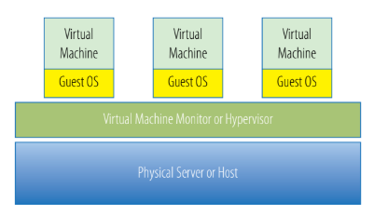

Q4] What is the difference between the VM, clone, snapshot and template?

**1. Virtual Machine (VM)**

A Virtual Machine (VM) is a complete, isolated environment that acts like a physical computer. It runs an operating system and applications just like a real machine but relies on a hypervisor (Virtual Machine Monitor, or VMM) to access the host's physical resources such as CPU, memory, and storage.

Components: Each VM consists of virtualized hardware (CPU, RAM, disk), a guest operating system (OS), and applications.

Example:

A VM might be running Windows Server 2019 and hosting a web application, while other VMs might run different operating systems like Linux or Ubuntu.

**2. Clone**

A Clone is an exact copy of an existing virtual machine. When you clone a VM, it creates a new VM that is identical to the original in terms of its operating system, applications, and settings at the time of cloning.

**Types:** There are typically two types of cloning:

* Full Clone: A complete, independent copy of the original VM. It does not rely on the original VM's disk, so it can be powered off or deleted without affecting the clone.
* Linked Clone: A clone that shares the base disk with the original VM. The linked clone uses the original disk for the core data but stores changes made to the clone in a separate file.

Example:

You might clone a VM running a web server to quickly set up multiple web servers with identical configurations.

**3. Snapshot**

A Snapshot is a point-in-time copy of the state of a virtual machine. It captures the current state of the VM, including its operating system, data, and configuration. This snapshot allows you to revert the VM back to this exact state if needed.

Characteristics:

* Snapshots don't create new VMs but preserve the state of the current VM.
* Snapshots are typically used for short-term purposes, as they can consume a significant amount of storage over time if not managed properly.

Example:

If you're testing a new software on a VM and want to be able to restore it to its original state if the software causes issues, you would take a snapshot before installing the software.

**4. Template**

A Template is a master copy of a virtual machine that has been configured with the desired operating system, applications, and settings. It is not intended for direct use, but rather as a base image from which multiple VMs can be deployed.

**Characteristics:**

* Templates are read-only. Once a VM is converted into a template, it cannot be modified. Any new VM created from the template will be a fresh instance.
* Templates are useful for deploying VMs in environments where consistency and standardization are important, such as in large-scale environments or cloud setups.

Example:

In an enterprise environment, a template might be created for a "standard" Windows Server 2019 configuration. Whenever a new server is needed, the template can be used to quickly deploy a new VM with that configuration.

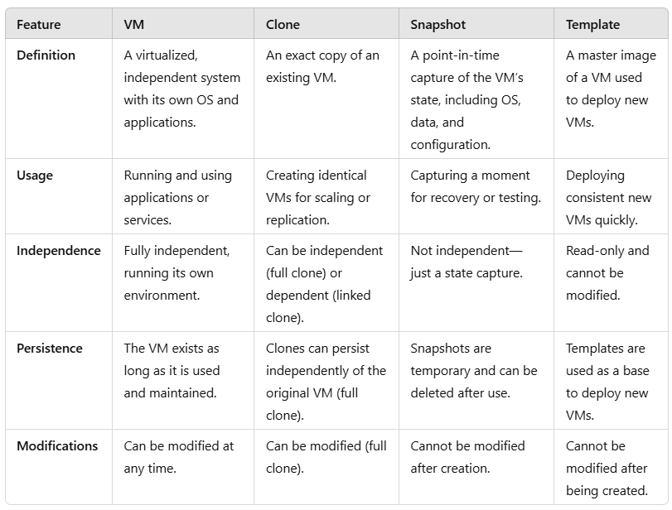

Q5] What is a container?

A container is a platform-independent package used to bundle, deliver, and deploy applications. While containers share similarities with virtual machines (VMs), they are different in several important ways, particularly in how they abstract resources.

**Characteristics:**

**OS Level Abstraction:** Unlike virtual machines, which abstract hardware resources (CPU, memory, etc.), containers provide abstraction at the operating system level. This means that containers run on a shared OS kernel, which allows multiple workloads (applications) to run in isolation within the same host environment but using the same operating system.

**Portability:** Containers are highly portable because they encapsulate an application and its dependencies into a single unit. This ensures that the application can run consistently across different environments—whether on a developer’s machine, test systems, or production environments. This portability is one of the reasons containers have gained popularity in application development and deployment.

**Lower Resource Overhead:** Since containers use the host OS’s kernel and do not require a full operating system like VMs, they have lower resource overhead. Containers are lightweight, making them quicker to deploy, faster to start, and more efficient in resource usage.

**Isolation:** While containers provide isolation between workloads, this isolation is not as robust as in virtual machines. In VMs, each guest OS operates independently with its own kernel, offering stronger isolation. In contrast, containers share the same kernel of the host OS, which means that the level of separation between workloads is somewhat weaker.

**Advantages of Containers:**

* **Rapid Deployment:** Containers can start almost instantly because they do not require booting an entire operating system.
* **Resource Efficiency:** Containers consume fewer resources than virtual machines since they share the same OS kernel rather than requiring a full operating system for each instance.
* **Portability:** Containers are highly portable and can be easily moved across different environments without changes in the way the application runs.

Q6] What is containerization?

Q7] How are I/O operations performed in a virtual environment?